User Manual

# Document Description

The user manual provides a comprehensive guide for playing the Text-Based Role Playing Adventure game. This document aims to ensure users, both novice and experienced, can enjoy a seamless and engaging gaming experience.

# Project Team

**Project lead of students**

Gössl, Marcel, if23b093@technikum-wien.at

**Project members** (Students)

Wirth, Sebastian, if23b296@technikum-wien.at

Schrenk, Dominik, if23b026@technikum-wien.at

Salem, Karim, if22b240@technikum-wien.at

Table of Contents

1. Document Description 1

2. Project Team 1

**Project lead of students** 1

**Project members** (Students) 1

3. System Requirements 2

4. Installation 2

5. Navigating 2

6. The Game 4

7. Tips and Tricks 5

8. Troubleshooting 5

9. Support 6

# System Requirements

To ensure the best experience, please make sure your system meets the following requirements:

* Operating System: Windows 7/8/10, macOS 10.12+, Linux
* Browser: Latest version of Google Chrome, Firefox, or Safari
* Software: Visual Studio Code

# Installation

For detailed instructions on how to set up the game environment, refer to the Deployment Manual.

# Navigating

If you see the following homepage, you had success with the installation!

Ein Bild, das Screenshot, Text, Haus enthält.

1. Select Story:

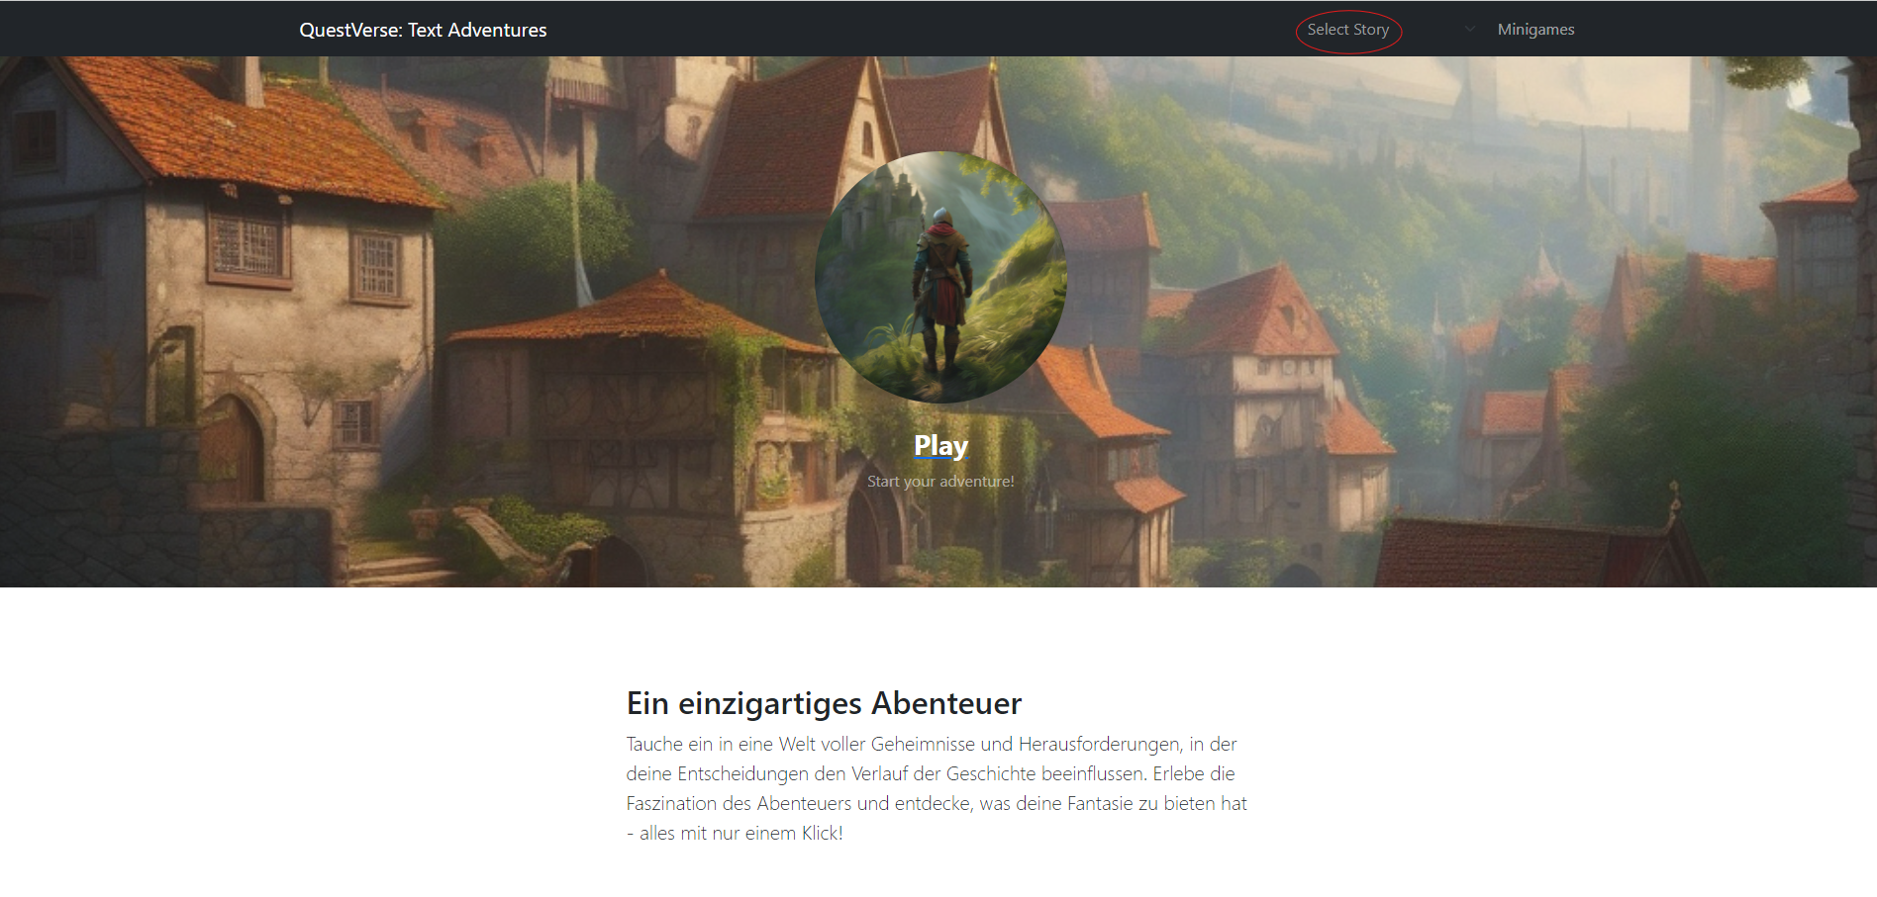

You can choose between two main stories:

Ein Bild, das Text, Schrift, Handschrift, Zahl enthält.

1. Start the story:

Ein Bild, das PC-Spiel, Kunst, Screenshot, Cartoon enthält.

After selecting the Story you can start the story by clicking the play button.

1. Minigames outside of the Story mode

You can scroll down and play the minigames without the story mode.

Ein Bild, das Text, Schrift, Screenshot, Logo enthält.

# 6. The Game

1. How to play in Story mode

Ein Bild, das Text, Software, Webseite, Website enthält.

You always get a text and some options. Choose wisely and click on the option you want to lock in.

1. Player stats:

Ein Bild, das Text, Schrift, weiß, Grafiken enthält.

The actual player stats throughout the game. The stats can change, it depends on which options you are clicking.

1. Minigames

There are some minigames in the game. You will figure out how to play them. Example:  
Ein Bild, das Gras, Pflanze, Cartoon, draußen enthält.

# Tips and Tricks

**HINT:** Don´t rush through the game. Take your time and think about the right option or you can die. (you don’t want to start all over again)

**HINT:** Try to remember what you choose. It will be important later in the game. Maybe even take notes.

**HINT:** READ CAREFULLY.

# Troubleshooting

1. Game won´t start:
   * Ensure you have followed all setup instructions in the Deployment Manual
   * Check that your browser is up to date.
2. Bugs or glitches:
   * Report any bugs or glitches to our support team with a detailed description.

# Support

If you need further assistance, feel free to reach out to our support team:

Gössl Marcel: [if23b093@technikum-wien.at](mailto:if23b093@technikum-wien.at) (Project Lead & Minigame Engineer)

Salem Karim: [if22b240@technikum-wien.at](mailto:if22b240@technikum-wien.at) (Senior Backend Engineer & Software Design)

Schrenk: Dominik, [if23b026@technikum-wien.at](mailto:if23b026@technikum-wien.at) (Senior Backend Engineer & Creative Thinking)

Wirth Sebastian: [if23b296@technikum-wien.at](mailto:if23b296@technikum-wien.at) (Senior Full stack Engineer & Frontend Design)